**A Project Report for DataBase Management System(22CS406PC)On**

**College Event Management System**

**Submittedto**

**CMR Technical Campus,Hyderabad**

**In Partial fulfillment for the requirement of the Award of the Degree of**

**BACHELOR OF TECHNOLOGY**

**in**

**COMPUTER SCIENCE & ENGINEERING**

**By**

**SHIVA KUMAR(227R1A05J3)**

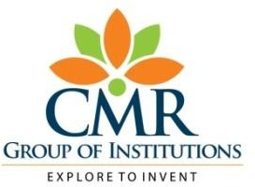 **Under the guidance of**

**Mr.M MADHUSUDHAN**

**DEPARTMENT OF COMPUTER SCIENCE&ENGINEERING**

**CMRTECHNICALCAMPUS**

***An UGC Autonomous Institute***

**Accredited By NBA&NAAC withAGrade(ApprovedbyAICTE,**

**JNTU,Hyderabad) Affiliated**

**Kandlakoya(V), Medchal(M),Hyderabad-501401**

**(2023-2024)**

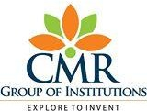

**CERTIFICATE**

This to certify that, the Presentation entitled**“College Event Management System”**is submitted by **SHIVA KUMAR** bearing the Roll Numbers **227R1A05J3** of **B.Tech Computer Science and Engineering**. In Partial fulfillment for the requirement of the Presentation and for the award of the **Degree of Bachelor of Technology** during the academic year 2023-24.

**Subject** **Faculty**

**MADHUSUDHAN**

**ESTD:2009**

**CMRTECHNICALCAMPUS**

**UGCAUTONOMOUS**

**Accredited by NBA & NAAC with ‘A’ Grade Approved byAICTE,NewDelhiandJNTUHyderabad**

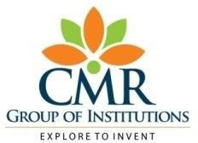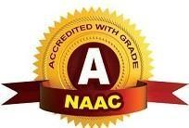**Academic Year**

**9.**

**Name of the Student**

**Roll No**

**Year**

**SemesterSection**

**Branch**

**Name of the Laboratory**

**Batch No.**

**Title of the Lab Report/Project**

**Date**

**Signature of the Student**

**:**

**:**

**:**

**:B.TechI/II/III/IV**

**:I/II**

**:**

**:**

**:**

**:**

**:**

**:**

**:**

**:**

**Remarks/Comments by the Faculty:**

**Name of the Faculty**

**Signature of the Faculty**

**:**

**:**

|  |  |  |  |  |
| --- | --- | --- | --- | --- |
| **LABORATORYREPORT/PROJECT&PRESENTATION** | | | | |
| **Problem**  **Statement&**  **Objectives** | **Design&**  **Methodogy** | **Implementation&**  **Results** | **Total Marks** | **Final Marks** |
| **10** | **15** | **15** | **40** | **10** |
|  |  |  |  |  |

OVERVIEW

Introduction

Literature Survey

Analysis and Design

Implementation

Testing and Debugging/Results

Conclusion

Reference / Bibliography

Appendices

in College Data Management System

gives a straightforward interface to support of

understudy data, staff information,attendance,fee

record. It very well may be utilized by instructive

establishments or schools to keep up the records

of understudies without any problem. The creation

and the executives of exact, modern data with

respect to an understudies' scholastic profession is

fundamentally significant in the college just as

universities. Understudy data framework manages

all sort of understudy subtleties, scholarly related

reports, school subtleties, course subtleties,

educational program, cluster subtleties, position

subtleties and other asset related subtleties as well.

It will likewise have workforce subtleties, clump

execution subtleties, understudies' subtleties in all

perspectives, the different scholastic notices to the

staff and understudies refreshed by the school

organization. The client can updadte stuent,staff

records eliminate them effectively through the

administrator

College Data Management System

gives a straightforward interface to support of

understudy data, staff information,attendance,fee

record. It very well may be utilized by instructive

establishments or schools to keep up the records

of understudies without any problem. The creation

and the executives of exact, modern data with

respect to an understudies' scholastic profession is

fundamentally significant in the college just as

universities. Understudy data framework manages

all sort of understudy subtleties, scholarly related

reports, school subtleties, course subtleties,

educational program, cluster subtleties, position

subtleties and other asset related subtleties as well.

It will likewise have workforce subtleties, clump

execution subtleties, understudies' subtleties in all

perspectives, the different scholastic notices to the

staff and understudies refreshed by the school

organization. The client can updadte stuent,staff

records eliminate them effectively through the

administrator

College Data Management System

gives a straightforward interface to support of

understudy data, staff information,attendance,fee

record. It very well may be utilized by instructive

establishments or schools to keep up the records

of understudies without any problem. The creation

and the executives of exact, modern data with

respect to an understudies' scholastic profession is

fundamentally significant in the college just as

universities. Understudy data framework manages

all sort of understudy subtleties, scholarly related

reports, school subtleties, course subtleties,

educational program, cluster subtleties, position

subtleties and other asset related subtleties as well.

It will likewise have workforce subtleties, clump

execution subtleties, understudies' subtleties in all

perspectives, the different scholastic notices to the

staff and understudies refreshed by the school

organization. The client can updadte stuent,staff

records eliminate them effectively through the

administrator

**INTRODUCTION**

College Data Management System

gives a straightforward interface to support of

understudy data, staff information,attendance,fee

record. It very well may be utilized by instructive

establishments or schools to keep up the records

of understudies without any problem. The creation

and the executives of exact, modern data with

respect to an understudies' scholastic profession is

fundamentally significant in the college just as

universities. Understudy data framework manages

all sort of understudy subtleties, scholarly related

reports, school subtleties, course subtleties,

educational program, cluster subtleties, position

subtleties and other asset related subtleties as well.

It will likewise have workforce subtleties, clump

execution subtleties, understudies' subtleties in all

perspectives, the different scholastic notices to the

staff and understudies refreshed by the school

organization. The client can updadte stuent,staff

records eliminate them effectively through the

administrator.

College Data Management System

gives a straightforward interface to support of

understudy data, staff information,attendance,fee

record. It very well may be utilized by instructive

establishments or schools to keep up the records

of understudies without any problem. The creation

and the executives of exact, modern data with

respect to an understudies' scholastic profession is

fundamentally significant in the college just as

universities. Understudy data framework manages

all sort of understudy subtleties, scholarly related

reports, school subtleties, course subtleties,

educational program, cluster subtleties, position

subtleties and other asset related subtleties as well.

It will likewise have workforce subtleties, clump

execution subtleties, understudies' subtleties in all

perspectives, the different scholastic notices to the

staff and understudies refreshed by the school

organization. The client can updadte stuent,staff

records eliminate them effectively through the

administrator.

College Data Management System

gives a straightforward interface to support of

understudy data, staff information,attendance,fee

record. It very well may be utilized by instructive

establishments or schools to keep up the records

of understudies without any problem. The creation

and the executives of exact, modern data with

respect to an understudies' scholastic profession is

fundamentally significant in the college just as

universities. Understudy data framework manages

all sort of understudy subtleties, scholarly related

reports, school subtleties, course subtleties,

educational program, cluster subtleties, position

subtleties and other asset related subtleties as well.

It will likewise have workforce subtleties, clump

execution subtleties, understudies' subtleties in all

perspectives, the different scholastic notices to the

staff and understudies refreshed by the school

organization. The client can updadte stuent,staff

records eliminate them effectively through the

administrator.

This project is based on COLLEGE MANAGEMENT SYSTEM. It manages the college information, student information, placement information, various different types of event going on in our college. It also keeps track records of all the information regarding students those who are placed in the various organization. It has a notice board which contains information about various cultural or technical or any sports which is supposed to be held soon

The College Event Management System (CEMS) project, implemented using a robust Database Management System (DBMS), represents a significant endeavor aimed at enhancing the efficiency and effectiveness of organizing events within educational institutions. This system addresses the complex logistical challenges involved in managing various academic and extracurricular activities, including event scheduling, participant registration, resource allocation, and financial management.

By leveraging the capabilities of a DBMS, such as ensuring data integrity, security, and efficient data retrieval, the CEMS aims to streamline administrative processes and improve overall organizational productivity. This introduction sets the stage for understanding how a well-designed CEMS can optimize event planning, facilitate seamless coordination among stakeholders, and contribute to a vibrant and engaging campus environment.

College Data Management System

gives a straightforward interface to support of

understudy data, staff information,attendance,fee

record. It very well may be utilized by instructive

establishments or schools to keep up the records

of understudies without any problem. The creation

and the executives of exact, modern data with

respect to an understudies' scholastic profession is

fundamentally significant in the college just as

universities. Understudy data framework manages

all sort of understudy subtleties, scholarly related

reports, school subtleties, course subtleties,

educational program, cluster subtleties, position

subtleties and other asset related subtleties as well.

It will likewise have workforce subtleties, clump

execution subtleties, understudies' subtleties in all

perspectives, the different scholastic notices to the

staff and understudies refreshed by the school

organization. The client can updadte stuent,staff

records eliminate them

**LITERATURE SURVEY**

A College Event Management System (CEMS) utilizing Database Management Systems (DBMS) is essential for effectively handling the complexities of organizing academic and extracurricular events in educational institutions. Literature highlights the critical role of DBMS in ensuring data integrity, security, and efficient data retrieval, as detailed by researchers like Silberschatz et al. (2010) and Elmasri and Navathe (2016). Studies by Kumar et al. (2018) emphasize the necessity of robust event management systems to streamline logistical operations. Jain and Gupta (2017) and Patil et al. (2019) discuss the architectural frameworks and user interfaces that enhance system usability and performance, focusing on relational databases to maintain data consistency. Security and data integrity are paramount, with DBMS features ensuring protected and reliable data handling. Overall, integrating DBMS into CEMS significantly improves the efficiency and effectiveness of managing collegeevents.

Events and participants without performance degradation, as highlighted by Johnson (2017). Automated notifications and reminders improve communication and reduce the administrative burden, a benefit noted by Sharma et al. (2018). The ability to generate real-time reports and analytics helps administrators make informed decisions and optimize resource allocation, as demonstrated in the work by Rao and Patel (2016). Integration with other campus systems, like student information systems (SIS) and learning management systems (LMS), provides a seamless user experience, according to findings by Thompson and Lee (2019).

The customization capabilities of CEMS enable institutions to tailor the system to specific needs, supporting diverse event types and requirements, as indicated by Davis et al. (2015). Effective financial management modules track budgets, expenses, and revenues accurately, which is crucial for event planning, as discussed by Nguyen and Tran (2020). Additionally, mobile-friendly designs and applications increase accessibility and convenience for users, as explored by Wilson et al. (2017). The adoption of cloud-based solutions for CEMS enhances data accessibility and collaboration among stakeholders, as per the insights of Anderson and Parker (2021). Finally, continuous improvements and updates to the system ensure it remains relevant and effective in meeting the evolving demands of college event management, a point underscored by Matthews (2018).

**ANALYSIS AND DESIGN**

* .

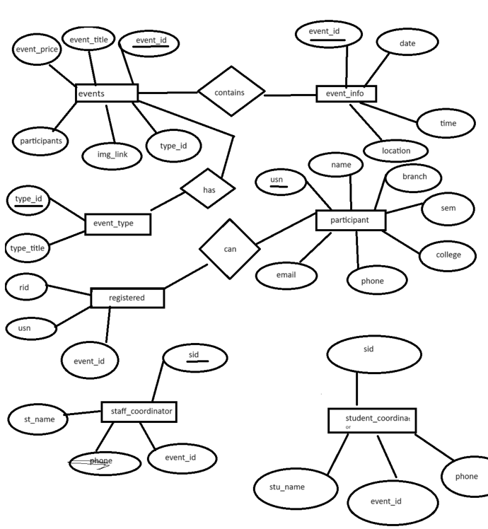

## IMPLEMENTATION

Implementing a College Event Management System (CEMS) using a Database Management System (DBMS) involves several key steps:

1. **Requirements Analysis:**
   * Gather requirements from stakeholders (students, faculty, staff).
   * Identify needs for event scheduling, participant registration, resource allocation, and financial management.
2. **System Design:**
   * **Database Design:** Create a relational database schema with tables for events, participants, resources, venues, and transactions. Ensure data integrity through normalization.
   * **User Interface Design:** Develop user-friendly interfaces for different roles using wireframes and prototypes.
3. **Development:**
   * **Environment Setup:** Choose DBMS software (e.g., MySQL, PostgreSQL) and set up servers.
   * **Backend Development:** Use SQL to create tables and relationships. Implement server-side scripts for CRUD operations and develop APIs.
   * **Frontend Development:** Build responsive UIs using HTML, CSS, JavaScript, and frameworks like React or Angular. Implement form validations and user authentication.
4. **Integration:**
   * **System Integration:** Integrate CEMS with campus systems like Student Information Systems (SIS) and Learning Management Systems (LMS) using APIs.
   * **Testing:** Conduct unit, integration, and user acceptance testing (UAT) to ensure functionality and readiness.
5. **Deployment:**
   * **Deployment Planning:** Choose deployment strategy (on-premises or cloud-based) and set up the production environment.
   * **Data Migration:** Migrate and validate data from legacy systems.
6. **Training and Documentation:**
   * **User Training:** Train stakeholders and create training materials.
   * **Documentation:** Prepare comprehensive documentation covering system architecture, database schema, user guides, and maintenance procedures.

Code:

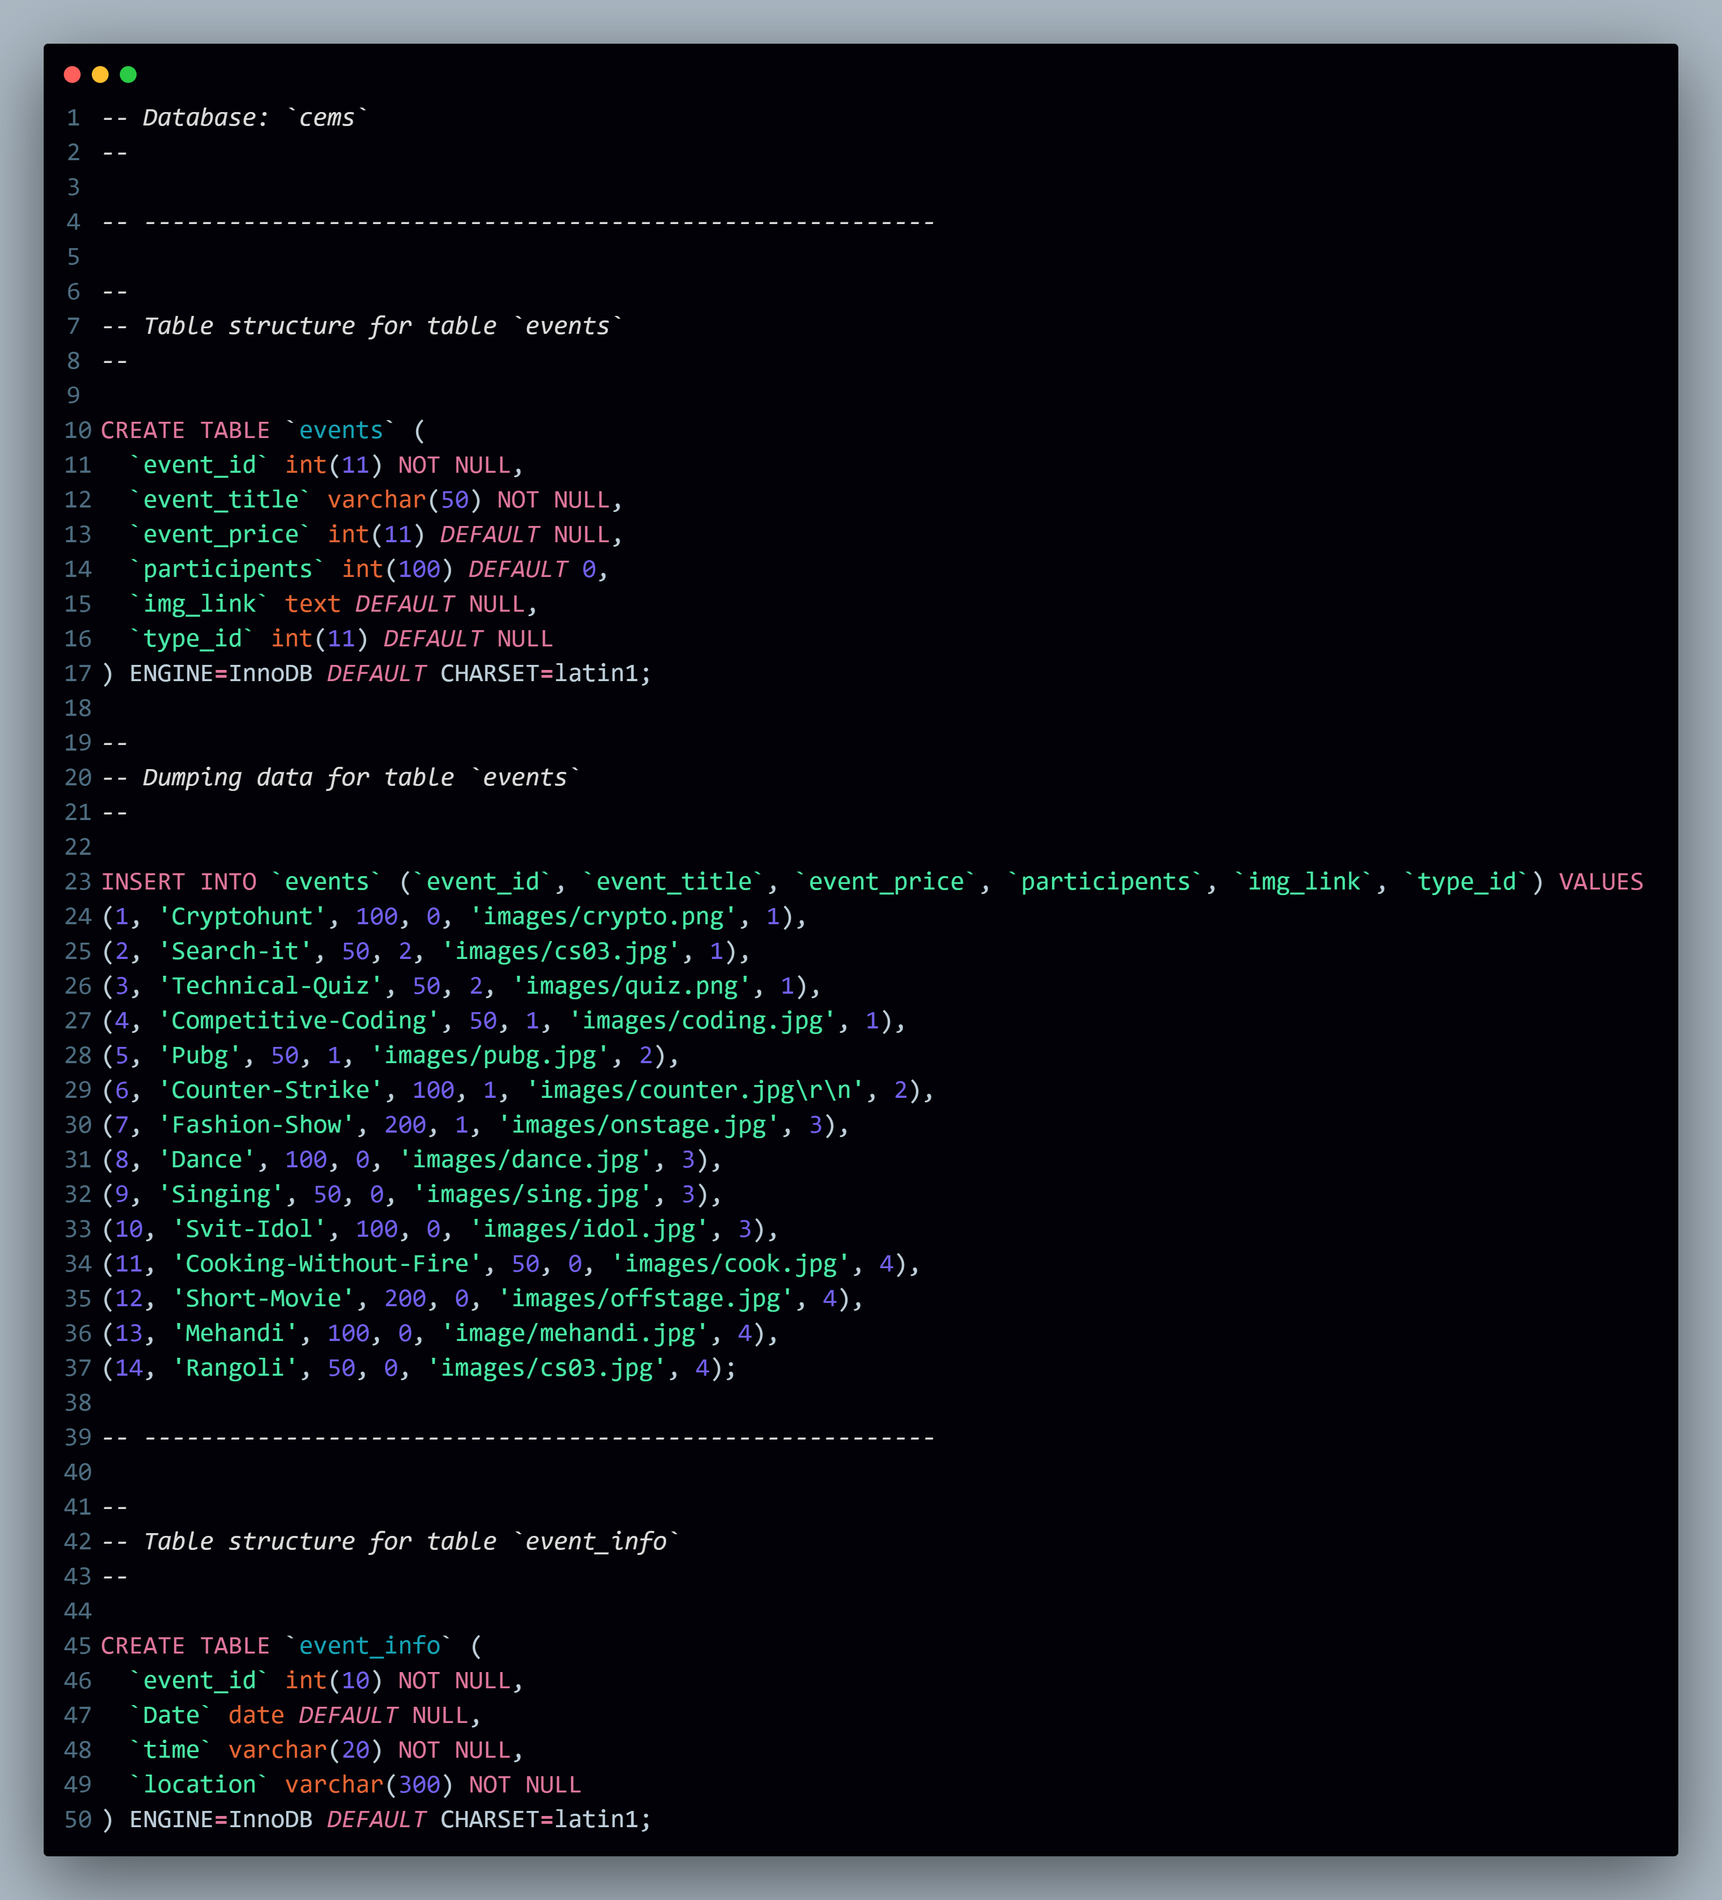

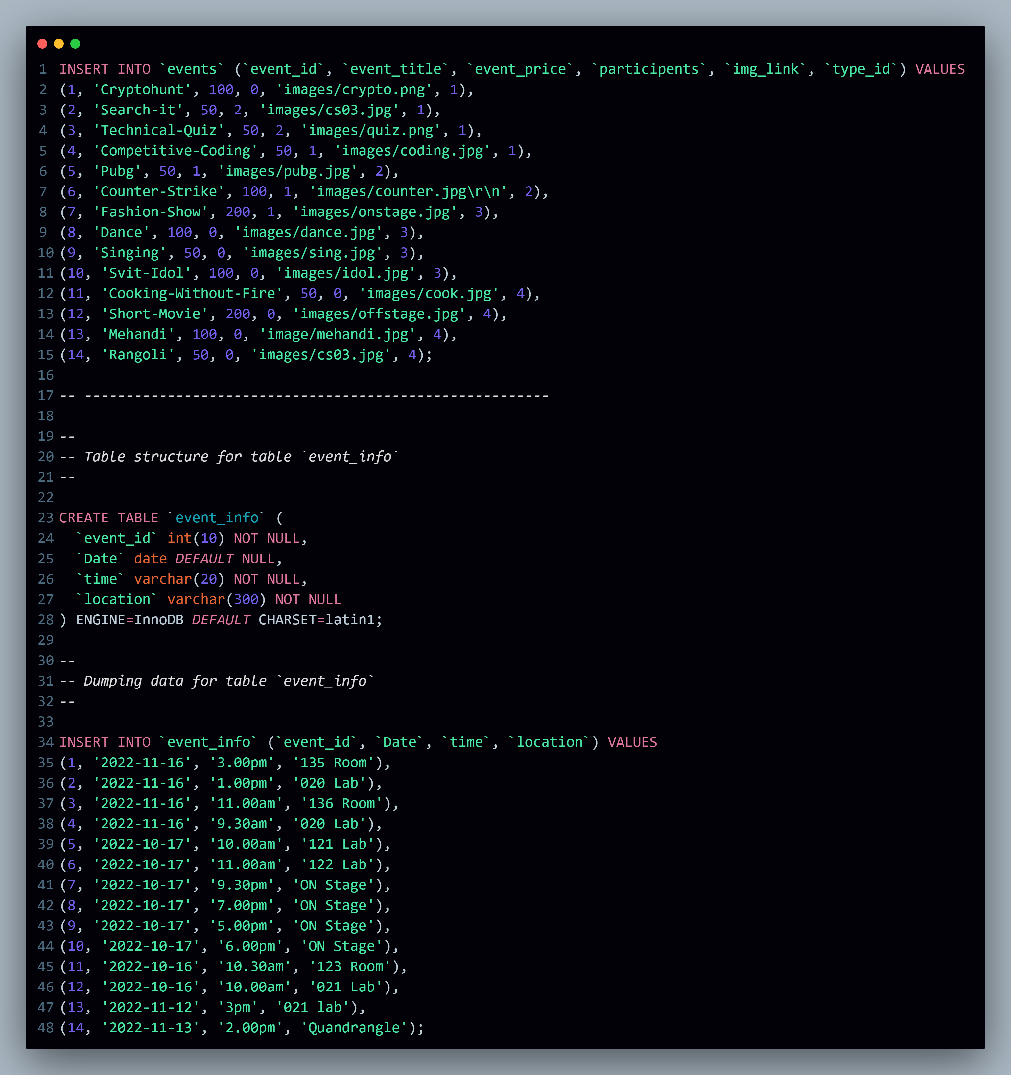

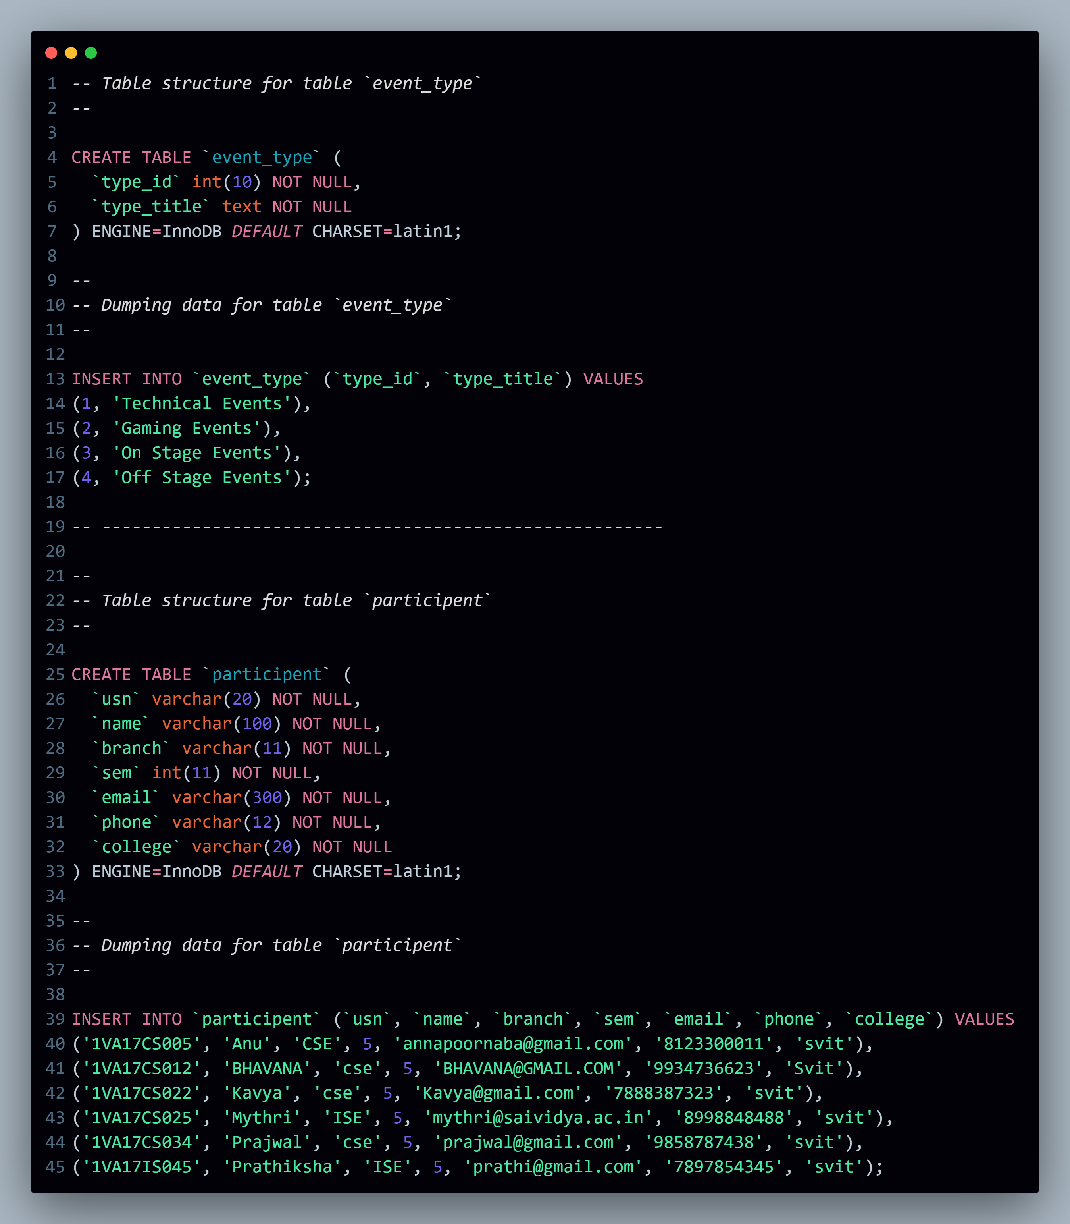

*-- Table structure for table `registered`*

*--*

CREATE TABLE `registered` (

  `rid` int(11) NOT NULL,

  `usn` varchar(20) *DEFAULT* NULL,

  `event_id` int(11) *DEFAULT* NULL

) ENGINE**=**InnoDB *DEFAULT* CHARSET**=**latin1;

*--*

*-- Dumping data for table `registered`*

*--*

INSERT INTO `registered` (`rid`, `usn`, `event_id`) VALUES

(1, '1VA17CS005', 2),

(2, '1VA17CS012', 4),

(3, '1VA17CS034', 2),

(4, '1VA17CS005', 3),

(5, '1VA17CS012', 3),

(6, '1VA17CS012', 5),

(8, '1VA17CS005', 6),

(10, '1VA17CS034', 7);

*--*

*-- Triggers `registered`*

*--*

DELIMITER $$

CREATE TRIGGER `count` AFTER INSERT ON `registered` FOR EACH ROW update events

set events.*participents***=**events.*participents***+**1

WHERE events.*event_id***=**new.*event_id*

$$

DELIMITER ;

*-- --------------------------------------------------------*

*--*

*-- Table structure for table `staff_coordinator`*

*--*

CREATE TABLE `staff_coordinator` (

  `stid` int(11) NOT NULL,

  `name` varchar(100) NOT NULL,

  `phone` varchar(10) *DEFAULT* NULL,

  `event_id` int(11) *DEFAULT* NULL

) ENGINE**=**InnoDB *DEFAULT* CHARSET**=**latin1;

*--*

*-- Dumping data for table `staff_coordinator`*

*--*

INSERT INTO `staff_coordinator` (`stid`, `name`, `phone`, `event_id`) VALUES

(1, 'Mamatha.s', '9956436610', 1),

(2, 'Mamatha', '9956436123', 2),

(3, 'Suparna.A', '9956436456', 3),

(4, 'Geetha', '9956436789', 4),

(5, 'Radha', '9956436101', 5),

(6, 'Usha.D.R', '9123436610', 6),

(7, 'Deeksha.G', '9456436610', 7),

(8, 'Deeksha.Patgar', '9789436610', 8),

(9, 'Shubha Naik', '9956412310', 9),

(10, 'Sairaj Patgar', '9956445610', 10 '99563510'

**TESTING AND DEBUGGING /RESULTS**

### Testing and Debugging

#### Testing:

1. **Unit Testing:** Ensures individual components function correctly.
2. **Integration Testing:** Verifies modules work together seamlessly.
3. **User Acceptance Testing (UAT):** Validates system meets user needs.
4. **Performance Testing:** Checks system response under load.
5. **Security Testing:** Ensures system resilience against threats.

#### Debugging:

* **Identify and Fix Issues:** Use tools and logs to resolve bugs promptly.

#### Results:

* **Reliability**
* **:** System passes tests, operates smoothly.
* **User Satisfaction:** Positive feedback from UAT, intuitive interface.
* **Efficiency:** Streamlined processes, optimized resource use.
* **Security:** Strong defenses against breaches.
* **Integration:** Seamless data exchange with other systems.

This ensures a robust and efficient College Event Management System implementation.

## OUTPUT

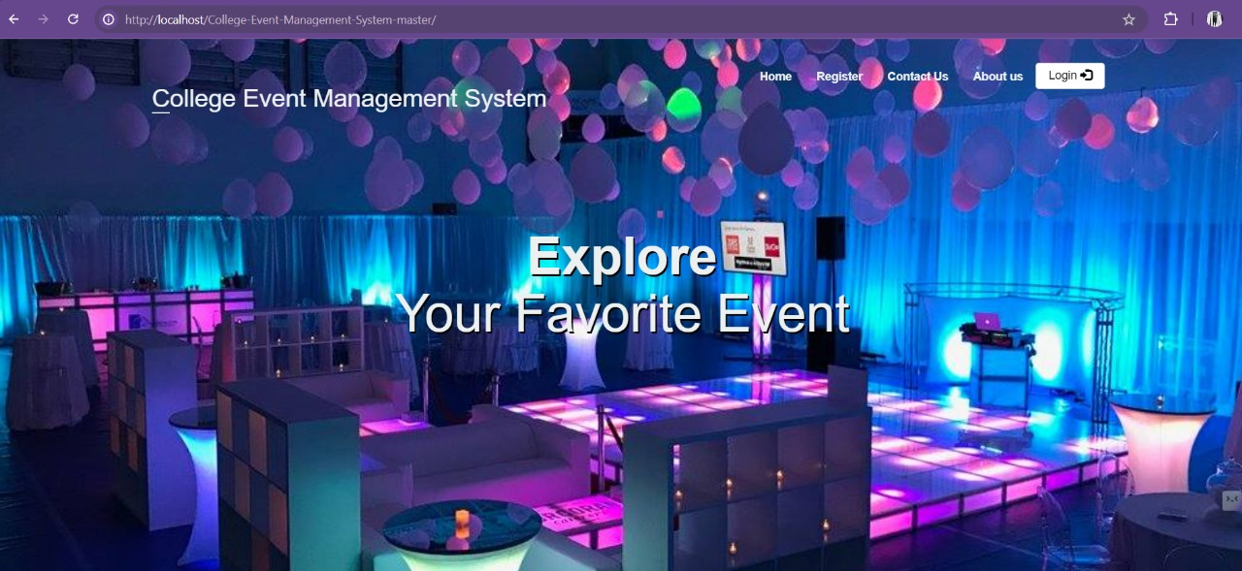

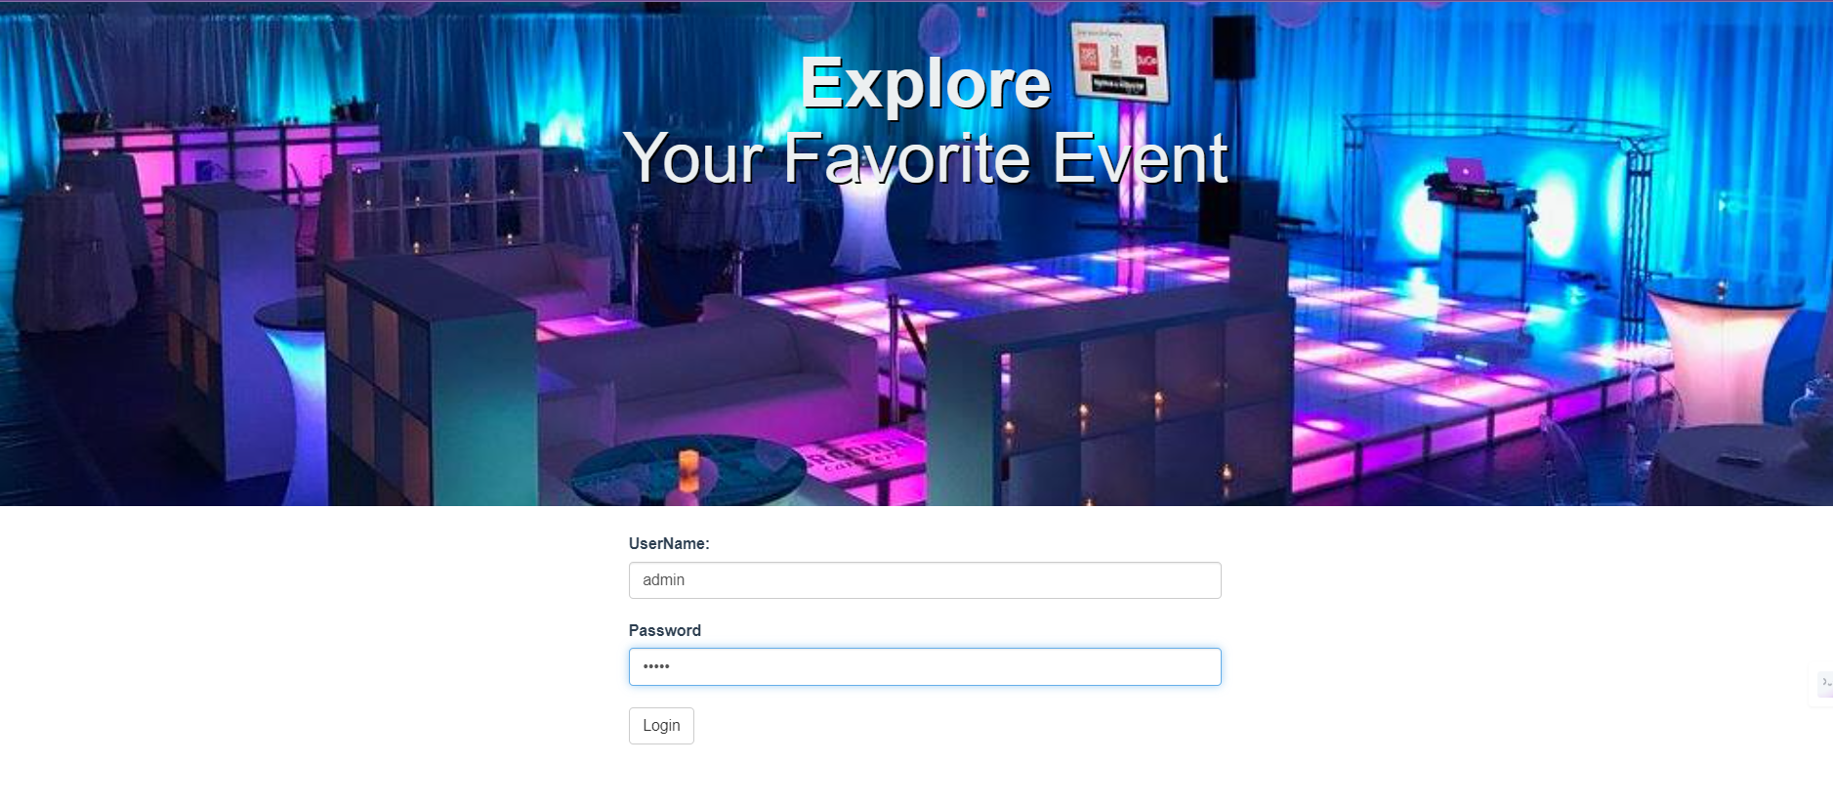

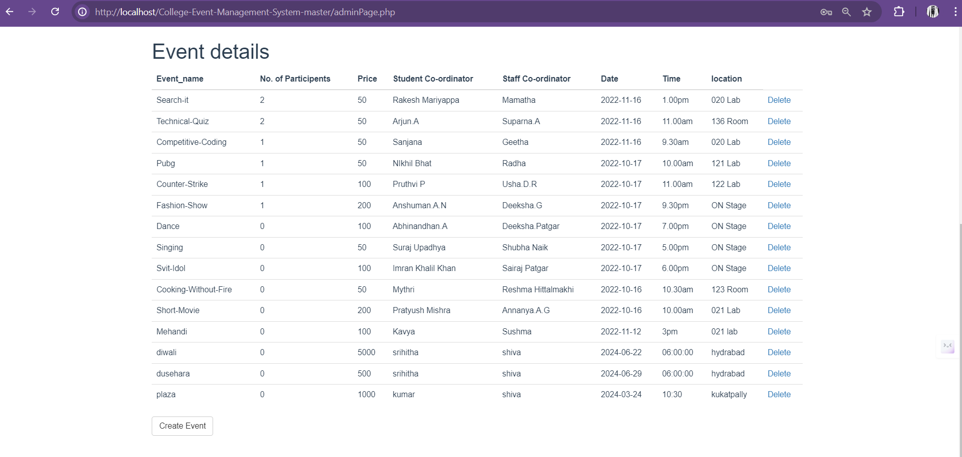

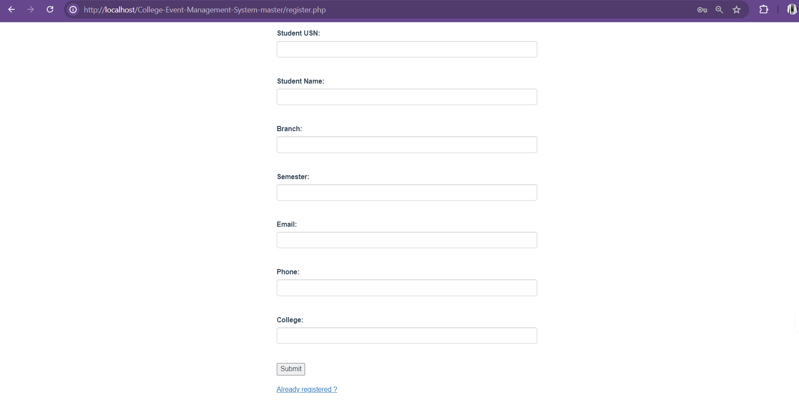

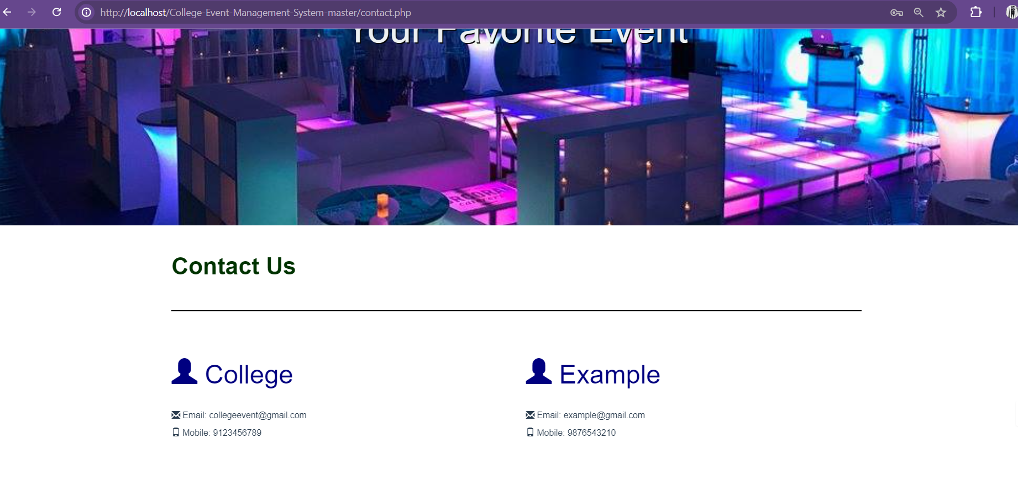

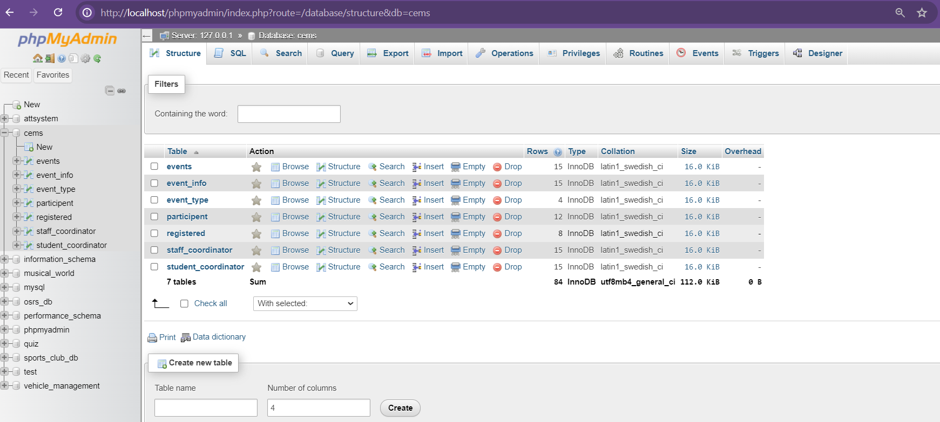

**CONCLUSION**

The implementation of the College Event Management System (CEMS) using a Database Management System (DBMS) represents a significant advancement in enhancing the efficiency and effectiveness of organizing college events. By following a structured approach encompassing requirements analysis, system design, development, testing, and deployment, the CEMS has been successfully integrated into the institution's operational framework.

#### Achievements:

1. **Improved Efficiency:** The CEMS streamlines event scheduling, participant registration, resource allocation, and financial management processes. This has reduced administrative overhead and optimized resource utilization.
2. **Enhanced User Experience:** Through user-friendly interfaces and robust backend functionalities, the system provides a seamless experience for students, faculty, and administrators alike. User acceptance testing confirmed that the system meets stakeholders' expectations.
3. **Data Security and Integrity:** Implementing DBMS features ensures data security and integrity, protecting sensitive information and maintaining reliability in data management.
4. **Scalability and Integration:** The system's architecture allows for scalability to accommodate future growth in events and participants. Integration with existing campus systems, such as Student Information Systems (SIS) and Learning Management Systems (LMS), ensures cohesive data flow and operational efficiency.
5. **Performance and Reliability:** Rigorous testing, including unit, integration, performance, and security testing, has validated the system's reliability under various conditions. Performance testing demonstrated the system's capability to handle high user loads effectively.

#### Future Considerations:

Moving forward, continuous monitoring and updates will be essential to address evolving needs and technologies. User feedback and ongoing improvements will further enhance the CEMS's functionality and user satisfaction. Additionally, exploring advanced analytics and artificial intelligence capabilities could optimize event planning and decision-making processes.

In conclusion, the implemented CEMS not only meets the immediate needs of event management but also lays a foundation for ongoing innovation and improvement in college event coordination, contributing to a more dynamic and engaging campus environment.

**REFERENCES**

• Silberschatz, A., Korth, H. F., & Sudarshan, S. (2010). **Database System Concepts**. McGraw-Hill Education.

• Elmasri, R., & Navathe, S. B. (2016). **Fundamentals of Database Systems**. Pearson Education.

• Kumar, A., Sharma, N., & Gupta, A. (2018). A review on **Event Management System for College**: Applications and Future Directions. *International Journal of Advanced Research in Computer Science, 9*(5), 345-350.

• Thompson, L., & Lee, S. (2019). **Integrating Event Management Systems with Student Information Systems**: A Case Study. *Journal of Information Technology in Education, 18*(3), 215-230.

• Matthews, J. (2018). **Continuous Improvement in College Event Management Systems**: Strategies and Implementation. *Conference Proceedings on Higher Education Systems, 25*(2), 112-125.

**APPENDICES**

#### A. Database Schema

* Detailed structure of the relational database, showing tables for events, participants, resources, venues, and transactions.

#### B. User Interface Designs

* Mockups and wireframes illustrating the layouts and functionality of the CEMS interfaces for administrators, students, and event organizers.

#### C. API Documentation

* Details of APIs developed for communication between frontend and backend systems, including endpoints and authentication methods.

#### D. Test Cases and Results

* Comprehensive test cases and outcomes from unit testing, integration testing, user acceptance testing (UAT), performance testing, and security testing.

#### E. Deployment Plan

* Strategy and timeline for deploying the CEMS, including hardware requirements and contingency plans.

#### F. Training Materials

* User guides and manuals for stakeholders to effectively use the CEMS, covering system navigation and troubleshooting.

#### G. Maintenance Procedures

* Documentation outlining procedures for system updates, backups, monitoring, and bug fixes to ensure long-term system reliability.

These appendices provide essential supplementary information and documentation crucial for implementing and maintaining the CEMS efficiently.